Siri Olson
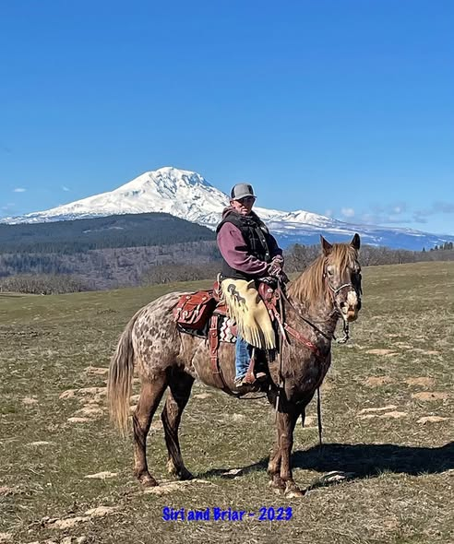
(PNER member #3354)
MY LIFE AS AN ENDURANCE RIDER, MAKING DREAMS COME TRUE!!
Meet your new PNER Vice President Siri Olson from Goldendale, WA. You'll be able to "spot" her smile on the trail!!
How/where did you first get involved in horses?
I grew up dreaming about horses with spots, wishing for one, because we could never afford one. Instead, I played with a variety of broken Breyer horses and rode friend’s horses when I could. When I was 12, I was placed with a family with horses. Is riding bareback a discipline? All I needed was a halter and a horse and I was off exploring, which often took me to the John Day River. I was drawn to a big ole Appy named Alpo. No one liked riding him and he was my favorite. Attitude, fund, ready to go at any time.
What breed(s) of equine do you currently own?
I got my very first horse when I was 20, when I was in college. Talka was an off the track thoroughbred that I used for team penning and gathering cows. As the years have flown by, I’ve had the pleasure of training, trail riding, camping, team penning, team sorting, and raising my son Zach with horses, where we always had a variety of horse training projects going on. I’ve owned Quarter Horses, Mustangs, Appaloosas, Arabians, and a few Heinz 57’s. We now have my retired Arabian mare, Appy-Arab cross, and 3 Appaloosas.
How/where did your involvement in horses turn into riding endurance?
I met Dee VanGilder in 1996, where she was my crew boss. Sherman County employed us to ride our horses to find and mark noxious weeds. Dee became the horse mom I never had. I fell in love with those beautiful and gallant VanGilder Arabians! Darcy Hollander found this 10-year-old Arab stallion that needed a new home. Darcy contacted Dee. Then Dee and her mom Margorie, went with me to Alfalfa, Oregon in my ’77 Ford pickup, through the awful winter weather and fog to get Saavy. He was a fiery little chestnut who was barely over 14 hands. Dee dragged me and my little spitfire Arabian, who had been gelded and only 30 days in training, to Stookey Stampede in 2000 for our first LD. I attribute my “endurance roots” to Dee. I spent several years at the LD level, but also spend quite a bit of time going to rides to volunteer, often with Dee in those early years.
What attracted you to endurance riding and what do you enjoy most about the sport?
I’ve always been drawn to setting goals and hard things. When I was younger, I remember seeing Mustang Lady on the cover of the AERC pamphlet going over Cougar Rock. At that time it was only a dream to even have my own horse, let alone be riding endurance. But I remember thinking “How cool is that!!” and if I had my horse would I be able to do that? My riding is mostly self-taught, I learned by jumping on and going, usually off the beaten path and making my own trails. The attraction to endurance riding for me is the challenge. It’s me and my horse against the trail, on any given day. We get to make the ride (competition or conditioning) what we want to make of it. Other’s have heard me say that I’m going out on a 50-mile trail ride, and I mean it! I love seeing all the beauty, the terrain, and experiencing something new every time we cross the start line. My heart is full when I am riding. I had to work to get to where I am personally, professionally, and I am able to fullfll lifelong dreams and I’m having a blast doing it!
What challenges have you face as an endurance rider and how have you overcome them?
Oh boy! Tough question! My horse always comes first! I think some of the toughest challenges comes from me wanting to take care of my horses the best I can and sometimes I fall short, for a variety of reasons. Maybe it’s because of the trail we had on that day, the weather, my fitness, mindset, and then throw in that my appaloosa gelding Trooper is not the “typical” endurance horse. Mindset is a huge challenge! There’s a level of mental preparation that goes into any ride I do, especially a 100-miler. When we are on a 100-mile ride, once we reach that 50-mile mark, it’s an entirely different ball game. I need to be mentally clear, open, and listening to my horse. I ride quite a bit by myself, it’s not because I don’t like people, it’s more because I need to focus on my horse and listen to him. Plus, I love spending time with him, even if he frustrates and pushes my buttons sometimes.
Tell us about your endurance ride history and accomplishments.
My miles don’t really speak to how long I’ve been in endurance. There were several years where I couldn’t afford to go to rides and then I was chasing our son around with school sports, 4-H, OHSET, ect… My biggest accomplishments are with Trooper! Who would’ve thought he would have come this far after his first 50-mile ride and Oregon 100 in 2015. This is the ride I rode with Bianca and he earned his name Trooper and received Vet’s Choice for the Northwest Appaloosa Endurance Championship, sponsored by DeWayne Brown. Since then we reached our Decade Team in 2025, won two Appaloosa National Distance Championships and BC for each, and 9 BCs. I’ve had 95 starts with 87 completions, which is a 91.5% completion rate. Troop has 60 starts, with 56 completions, which is a 93% completion rate. On 100’s he has 11 starts with 9 finishes. My greatest accomplishment is Troop. From where we started to where we have come, with the completion rates we have is what I am most proud of. He made me a true endurance rider, testing me most of the way, and I helped him find his calling in becoming an endurance horse.
Who is your current mount or who was a favorite beloved mount?
Troop is coming up on 16 in 2026. Hoping to be able to keep him going for a few more years.
Favorite memory riding endurance or participating in any form at an endurance ride?
I have so many! I have an endurance family, which is something I don’t take for granted. One of my favorite memories was riding with Max, Darlene, and Tani at Grizzly in 2022. We had big plans to go to Tevis that year, so Grizzly 75 was the goal. We were miserably cold. It snowed, the trail was sloggy, it hailed side-ways. Ice pelts were bouncing off the horse’s faces. And yet, we had a fabulous time! Jala got a good picture of us that made the EN cover, of us flying through the air in the SNOW! We laughed, complained, and enjoyed each other’s company. Thank you Lois for the vodka trees!
Best lesson learned (from your personal experience or from others)?
It’s okay to not be 110% prepared all the time! There is no way to plan for absolutely everything. What is important is being able to be flexible and adaptable. Endurance brings everyone together, if you need help ask for it, there will always be someone to that will step in and help, regardless of the situation. ASK FOR HELP! Keep smiling and keep laughing!! This is supposed to be fun, not just endurance, but LIFE. Enjoy the ride!! Make the most of it!
What advice would you offer to someone who is new to the endurance world?
If you’re new to the endurance world, come find me!! I don’t know everything, but happy to share my experience. Also, don’t be afraid to jump in! You won’t know what you can accomplish until you try. I remember making that leap from LDs to 50’s. Totally out of my comfort zone. I didn’t have a mentor, but I was going to try. I may have been sore for a couple of days, but I did not die! Keep it simple!!! Endurance is hard enough with out over complicating it.
What prompted you to become a PNER member? When did you first become a member?
Well, Dee took me to a couple of conventions, met a few people, and became a member, not really knowing what I was getting into. The greatest value of my membership is the friends and family I have gained along the way.

